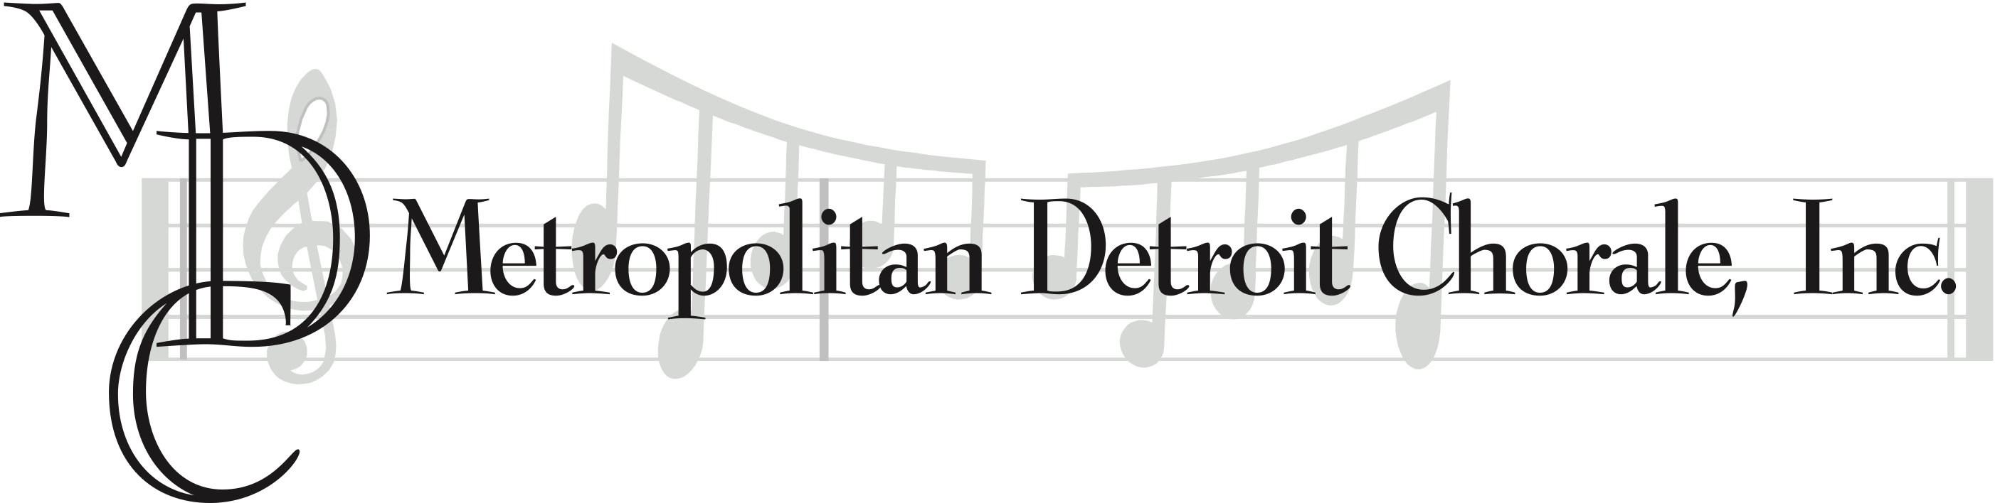
The Richard and Carol Mox
Young Artist Music Competition Scholarship

Applications Due: Tuesday, March 26, 2019
if mailing application, mail by Friday, March 22

Auditions: Tuesday, April 16, 2019 • 6:30 pm

Who is eligible?
Students wishing to apply must meet the following criteria:
• Must be accepted to a college or university pursuing a degree in any area of music and have successfully completed any required auditions.
• Must demonstrate an exceptional past commitment to music
• Must have at least a 3.0 grade point average
• Must be expecting to graduate from Fraser High School at the end
of the school year in which he/she is applying

Where do I get an application?
Forms and information are available at Student Services
and online at www.metropolitandetroitchorale.org

When should I get a form?
Get it now so that you will have time to complete all parts
of the application.

